NADKO DENTALS TEST REPORT

V.1.0 2021

|  |  |  |
| --- | --- | --- |
| Version | Date | State |
| 1.0 | 20 June 2021 | Initial Release |

Contents

E2E testing 2

Unit Testing 3

Quality Assurance Testing 4

User Acceptance Testing and UX feedback. 4

User Acceptance Testing 4

UX Feedback 6

# E2E testing

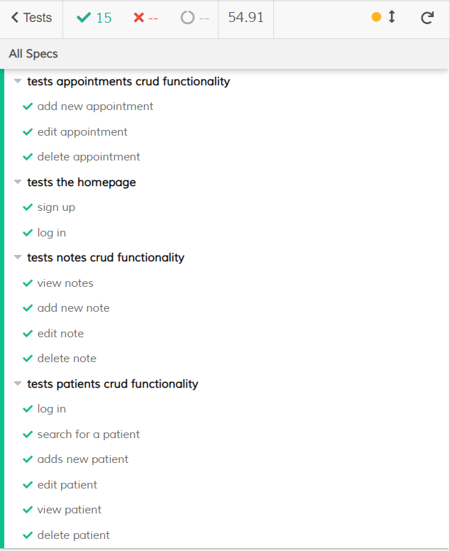

# Unit Testing

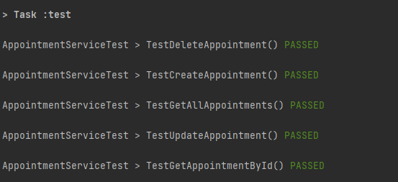

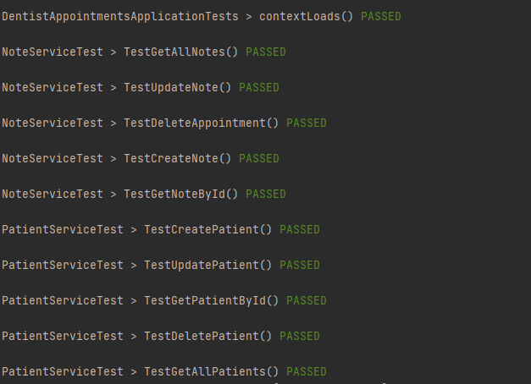

# Quality Assurance Testing

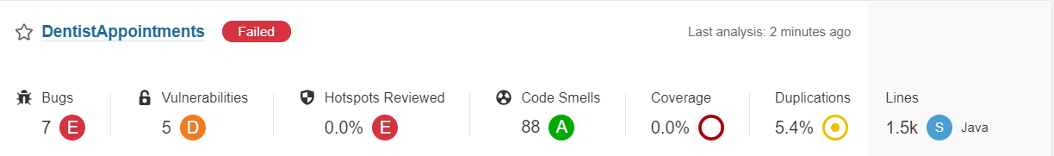

# User Acceptance Testing and UX feedback.

## User Acceptance Testing

The User Acceptance Tests were fully handled by the E2E tests, however some were performed with live users so that UX feedback can be obtained.

|  |  |  |  |  |  |
| --- | --- | --- | --- | --- | --- |
| Test No. | Test Name | Test Purpose | Test Data/Directions | Expected result | Result |
| 1. | Sign Up | Test that a user is created in the database with their assigned role. | Username: testDentist Email: [test@email.com](mailto:test@email.com)  Password: password  Role: dentist | A user with the given credentials is created into the database. | ✅ |
| 2. | Log In | Test that a previously created user can log in with their credentials. | Username: testDentist Password: password | The user can access their profile page. | ✅ |
| 3. | Add patient | Test if the dentist can add a patient to their list of patients | First Name: test  Last Name: test  Email: [test@gmail.com](mailto:test@gmail.com)  Phone: +3112837621 | The new patient is added to the user’s list of patients. | ✅ |
| 4. | Edit patient | Test if the dentist can edit the patient’s information. | First Name: testPatient | The new patient has their name changed from “test” to “testPatient” | ✅ |
| 5. | Search for a patient | Test if the search functionality works | Search: testPatient | “testPatient” appears in the search results | ✅ |
| 6. | View patient | Test if the dentist can view the patient’s personal pages where they can see their notes about the patient | Click on the “View” button of the selected patient | The dentist can see the patient’s data and their own notes about that patient. | ✅ |
| 7. | Delete patient | Test if the dentist can remove a patient from their list of patients | Click on the “Remove” button of the selected patient | The removed patient is no longer displayed in the list of patients. | ✅ |
| 8. | Add note | Test if the dentist can add a note about a patient | Note content: “Note about a patient” | The dentist can see the newly-added note in the patient’s info page. | ✅ |
| 9. | Edit note | Test if the dentist can edit a note they created beforehand | Note content: “Note about a patient (edited)” | The dentist can see the updated note content with updated date and time. | ✅ |
| 10. | Delete note | Test if the dentist can delete a note they previously created | Click on the trash can icon on the note that needs to be deleted. | The removed note is no longer visible. | ✅ |
| 11. | Create an appointment | Test if the dentist can create a new appointment for their patient | Patient: choose from a dropdown list of patients Appointment Time: select a date and time for the appointment. | The new appointment is displayed in the list of appointments. | ✅ |
| 12. | Edit an appointment | Test if a dentist can edit the appointment they previously created | Change either the time of the appointment or the patient who visits | The edited appointment has its data changed to the edited data. | ✅ |
| 13. | Remove an appointment | Test if the dentist can remove and appointment from their list of appointments | Click on the “Remove” button of the selected appointment. | The removed appointment is no longer shown in the list of appointments. | ✅ |

## UX Feedback

1. Test Name: Sign Up

Test-user name: Yasen Georgiev

Result and Feedback: The test-user was able to register themselves however they didn’t like that they have to input their role manually and suggested that maybe a dropdown menu would be good to have so that all available options are shown.

1. Test Name: Edit Patient

Test-user name: Yanislava Stefanova

Result and Feedback: The test-user was able to successfully edit several patients’ information, however during the testing they accidentally hit the delete button for one of the patients and deleted them. After that they voiced their concerns that such a problem may occur in the future and a deletion prompt would be nice to have to prevent that.

1. Test Name: Add Note

Test-user name: Veselin Manev

Results and Feedback: The test-user managed to create a new note for one of the patients however when that note was created the website’s body went below the footer and the footer was covering some of the content. As a result the number of notes has been limited to 3 per page with the added option of switching between the numerous pages. Furthermore a CSS update is needed to make sure that doesn’t happen with other elements that go below the footer’s level.